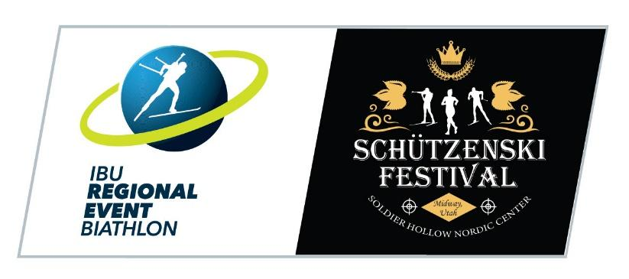

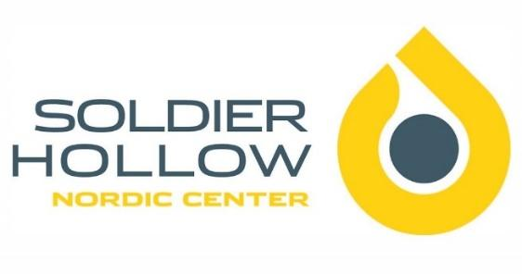

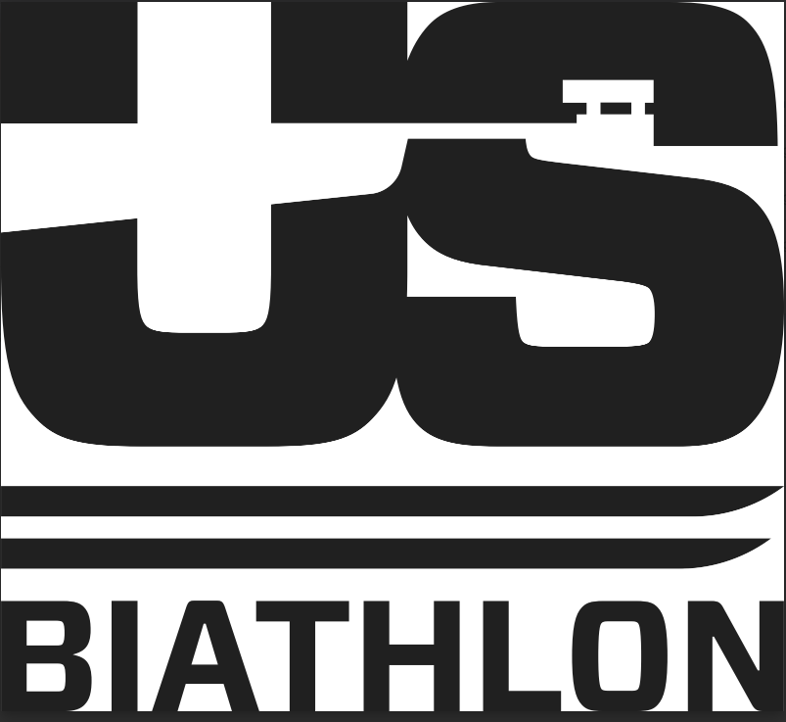

Soldier Hollow Nordic Center
Presents

IBU Regional Event - 2025 USBA Fall Festival & International Team Trials

October 2nd - 4th, 2025

Hosted by

Soldier Hollow Nordic Center
2002 Soldier Hollow Ln.
Midway, UT 84049

Event Administrator – Josh Korn
(801) 624-0809
jkorn@uolf.org

U.S. Biathlon Event Liaison – John Farra
(719) 744-2842
jfarra@usbiathlon.org

Local Organizing Committee Liaison – Gerrit Garberich
(218) 839-6340
ggarberich@uolf.org

Chief of Venue – Bill Pierce
(612) 590-1427
bpierce@uolf.org

Chief of Competition – Shawn Robison
Technical Delegate – Sara Studebaker-Hall
Chief of Range – Konrad Thiel
Assistant Chief of Range – Andre Crouch
Chief of Course – John Barrick
Chief of Timing/Stadium – Curtis Lupo
Timing Contractor – Muddy Dog Sports
Announcers – Brock Van de Camp & Kate Mulcahy-Halligan
Medical Coordinator, IHC – Jennifer Kimball
Volunteer Coordinator – Kenzie Bennion

Welcome

Soldier Hollow Nordic center would like to invite you to attend the 2025 USBA Fall Festival and International Team Trials. These races are annually run at Soldier as part of our Schutzenski Festival.

Soldier Hollow is a 440-acre venue with 31km of trails located just an hour drive from the Salt Lake International Airport.

Nestled above the picturesque town of Midway and resting in the shadow of the Wasatch Mountains lies Soldier Hollow Nordic Center at Wasatch Mountain State Park. Although it is primarily known as an Olympic venue, Soldier Hollow hosts a variety of activities throughout the fall, spring and summer. Athletes at world-class levels and weekend enthusiasts can enjoy the facility on a year-round basis. The newly renovated Competition Center serves as the nerve center for major events, ranging from U.S. Cross Country Skiing Championships, IBU World Cups, Youth and Junior World Championships, Junior XC Nationals and NCAA Championships.

Rules

International Biathlon Union Event and Competition Rules will be in effect for this event, except as specifically modified by the Organizing Committee or Competition Jury. Any modifications to the rules will be discussed at the Team Captains Meeting. The organizing committee reserves the right to modify the parameters of the event based upon local conditions such as weather and trail availability. The use of safety markers (IBU Rule 8.5.1) will be required when rifles are not in use.

Eligibility

If correctly registered and entered by USBA Region or their Canadian Division any member of USBA or Biathlon Canada in good standing and born up to and including the year 2013 may participate in this event if they have a valid USBA or Biathlon Canada Competitor membership card.

Team Captains Meeting

There is one team Captains Meeting scheduled for this competition. It will be held on the second floor of the newly renovated Competition Building at 5:00pm on Thursday October 2nd.

Age Classes

Age class is determined by your birth year and remains constant throughout the racing year which starts in the summer and concludes in the spring. Please consult the following table to determine your age classification for the 2025-26 season.

Year Born | 2025-26 Age | Class Names | 2025-26 USBA Rifle Handling Class
1995-before 1956 | 30-70+ | Master Women & Men | Racking Class
2004 + | 21-29 | Senior 21+ (Open) Women & Men* | Carry Class
2005, 2006 | 19-20 | Junior U21 Women & Men* | Carry Class
2007, 2008 | 17-18 | Youth U19 Women & Men* | Racking Class
2009, 2010 | 15-16 | Youth U17 Girls & Boys* | Racking Class
2011, 2012 | 13-14 | Under 15 Girls & Boys | Cuff: Racking Class  Block: Mat Class
2013, 2014 | 11-12 | Under 13 Girls & Boys | Cuff: Racking Class  Block: Mat Class
* Note the new IBU competition classes and age mapping for IBU Classes for the 2025-25 season:
Senior: Age 21 and up
Junior U21: Ages 19 & 20
Youth U19: Ages 17 & 18
Youth U17: Ages 15 & 16

For this competition, all Youths will race together in the IBU Youth U19 Class.

Competition

The competition will include an Elite Sprint race on Friday Oct 3rd, and an Elite Mass Start race on Saturday Oct 4th. There will also be an Open Division Sprint on Friday and an Open Division Mass Start on Saturday.

2025 U.S. Biathlon Fall Festival & International Team Trials Schedule:
Thursday October 2nd:
8:00 - 8:30am U.S. Biathlon Coaches check-in/Registration confirmation (range)
8:00 - 10:30am Biathlon Sprint Official Training
5:00 – 5:15pm: BIA - Coaches meeting @ The Sports Discovery Center (main level)
Friday October 3rd:
7:45 - 8:45am: Athlete check-in & Bib pick up (North side of Sports Discovery Center)
8:00 – 8:50am: Biathlon Elite M/W Zero
9:00 – 9:45am: Biathlon Elite M 10km Sprint
10:00 – 10:45am: Biathlon Elite W 7.5km Sprint
10:45 – 11:20am: OPEN Class Zero
11:30 – 12:15pm: Biathlon 5km M/W Sprint OPEN
12:30 – 12:45pm: Annual SOHO Biathlon Shoot-out
1:00 - 1:15pm: Awards

Saturday October 4th:
7:45 - 8:45am: Athlete check-in & Bib pick up (North side of Sports Discovery Center)
8:00 – 8:50am: Zero Elite W/M
9:00 – 9:45am: Biathlon W 10km Mass Start
10:00 – 10:45am: Biathlon M 12.5km Mass Start
10:45 – 11:30am: Biathlon M 12.5km Mass Start (Wave 2)
12:00 – 12:20pm: Elite Awards
12:00 – 12:35pm: OPEN Class Zero
12:45 – 1:30pm: Biathlon OPEN 7.5km Mass Start
1:45 – 2:00pm: Open Class Awards

Unofficial Training and Events

Open training will be available on the venue on the days leading up to the competition days. More details to come on when the courses will be marked. Rollerski Trail fees and Range fees will be required. For those of you training on the venue for 10+ days, taking advantage of a Season Pass will be the best deal. Daily venue fee structure below:

Daily Rollerski Pass adult = $12.00
Daily Rollerski Pass U18 = $8.00
Daily Range Fee = $10.00

These passes can be purchased at the Lodge upon arrival.

We are also offering a Biathlon Camp Pass (Sept 29 – Oct 4) which includes both races.
Camp Price (4 training days + 2 races) = $130.00

Awards

Awards will be presented following each of the races, to the top three finishers in each of the competition classes.

Registration and Fees

Race and Camp Registration (ALL COACHES MUST ALSO REGISTER)
One Race = $45.00 / Two races = $80.00

Event Page

Event Website

Course Maps

Women’s Elite Courses

Friday 7.5k Sprint

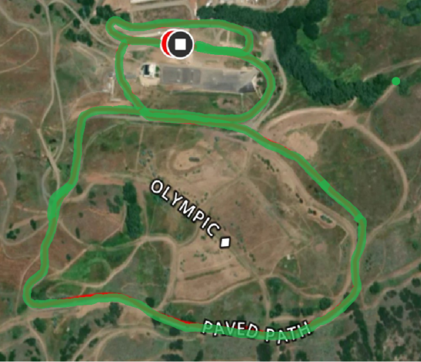

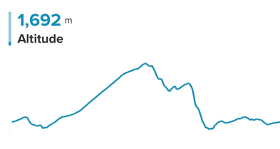

Elite Women Sprint COURSE MAP

50 METERS OF GAIN PER LAP

Women’s Elite Courses

Saturday 10k Mass Start

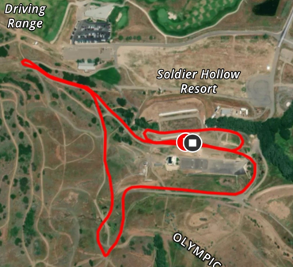

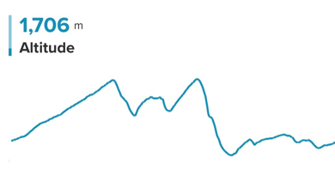

Elite Women Mass Start COURSE MAP

40 METERS OF GAIN PER LAP

Men’s Elite Courses

Friday 10k Sprint

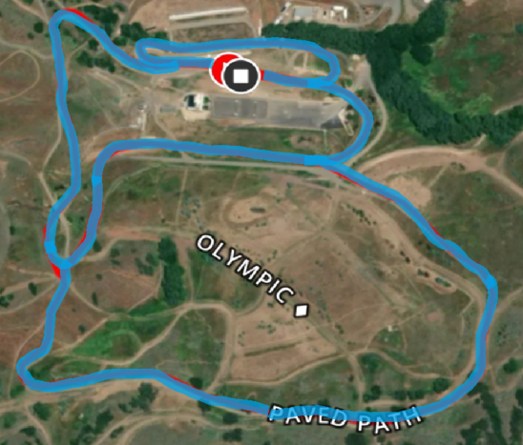

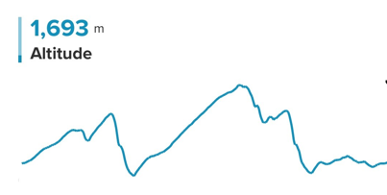

Elite Men Sprint COURSE MAP

72 METERS OF GAIN PER LAP

Men’s Elite Courses

Saturday 12.5k Mass Start

Elite Men Mass Start COURSE MAP

50 METERS OF GAIN PER LAP

Men’s / Women’s Open Course

Friday 5k Sprint

Saturday 7.5k Mass Start

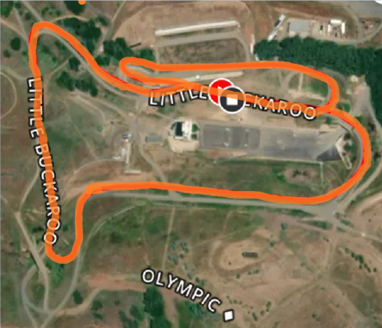

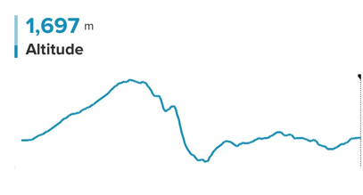
OPEN COURSE MAP
23 METERS OF GAIN PER LAP

Lodging

Heber Valley is home to a variety of lodging and dining options for teams, athletes, families, and friends, among them are Homestead and Zermatt Utah in Midway, Utah. Contact information can be found for all options on the local chamber website at www.gohebervalley.com.

Zermatt Utah
784 West Resort Drive, Midway, UT 84049
For individuals, families, or teams under 10, please call Zermatt reservations 435.709.9527 and ask for the ‘Soldier Hollow’ rate (based on availability). The rate offered for all room types will be 15% off the best price on Zermatt’s website.
Group Reservations (10 or more rooms per night)
- Contact: Zermatt Sales
- rfp@zermattresorts.com
Midway Vacation Properties
(home, condo, townhome rentals)
Website: staymvp.com Midway Vacation Properties 840 W Bigler Lane
Midway, UT 84049
(888) 435 4204
info@midwayvp.com

Residences at Utah Olympic Park
Book a stay to take advantage of:
- Park City’s best nightly lodging rates
- Modern Hotel Rooms
- Unbeatable proximity to the Utah Olympic Park and surrounding ski resorts
- Guest kitchen and catering space to take care of all your meal needs.
- Complementary meeting/video review space
More information about our facility and accommodations can be found here.
Book your discounted event lodging with us here: https://hotels.cloudbeds.com/reservation/ggdeS7#promo=Comp23%2F24

Best Western Plus Heber Valley Hotel
Hotel Website
1227 S. US Highway 40
Heber City, UT 84032
435-657-6500

