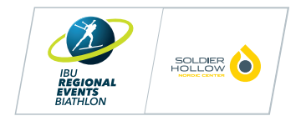



Soldier Hollow Nordic Center
Presents

IBU Regional Event – 2026 U.S. Biathlon Senior Nationals & Spring Festival

March 26 – 29, 2026

Hosted by

Soldier Hollow Nordic Center
2002 Soldier Hollow Ln.
Midway, UT 84049

Event Administrator – Josh Korn
(801) 624-0809
jkorn@uolf.org

U.S. Biathlon Event Liaison – Sara Studebaker-Hall
(208) 340-5489
sara@usbiathlon.org

Local Organizing Committee Liaison – Gerrit Garberich
(218) 839-6340
ggarberich@uolf.org

Chief of Venue – Bill Pierce
(612) 590-1427
bpierce@uolf.org

Chief of Competition – John Barrick
Technical Delegate – Shawn Robison
International Referee, Range – Ken Meich
Chief of Range – Konrad Thiel
Chief of Course – Zach Hall
Chief of Timing/Stadium – Curtis Lupo
Timing Contractor – Muddy Dog Sports
Announcers – Matt Heimburger
Medical Coordinator, IHC – Jennifer Kimball
Volunteer Coordinator – Kenzie Bennion

Welcome

Soldier Hollow Nordic center would like to invite you to attend the 2026 U.S. Biathlon Senior Nationals & Spring Festival, March 26th – 29th, 2026.

Soldier Hollow is a 440-acre venue with 31km of trails located just an hour drive from the Salt Lake International Airport.

Nestled above the picturesque town of Midway and resting in the shadow of the Wasatch Mountains lies Soldier Hollow Nordic Center at Wasatch Mountain State Park. Although it is primarily known as an Olympic venue, Soldier Hollow hosts a variety of activities throughout the fall, spring and summer. Athletes at world-class levels and weekend enthusiasts can enjoy the facility on a year-round basis. The newly renovated Competition Center serves as the nerve center for major events, ranging from U.S. Cross Country Skiing Championships, IBU World Cups, Youth and Junior World Championships, Junior XC Nationals and NCAA Championships.

Rules

International Biathlon Union Event and Competition Rules will be in effect for this event, except as specifically modified by the Organizing Committee or Competition Jury. Any modifications to the rules will be discussed at the Team Captains Meeting. The organizing committee reserves the right to modify the parameters of the event based upon local conditions such as weather and trail availability. The use of safety markers (IBU Rule 8.5.1) will be required when rifles are not in use.

Eligibility

If correctly registered and entered by USBA Region or their Canadian Division any member of USBA or Biathlon Canada in good standing and born up to and including the year 2013 may participate in this event if they have a valid USBA or Biathlon Canada Competitor membership card.

Team Captains Meeting

There is one team Captains Meeting scheduled for this competition. This will be a virtual meeting taking place at 4:00pm on Thursday March 26th.

Age Classes

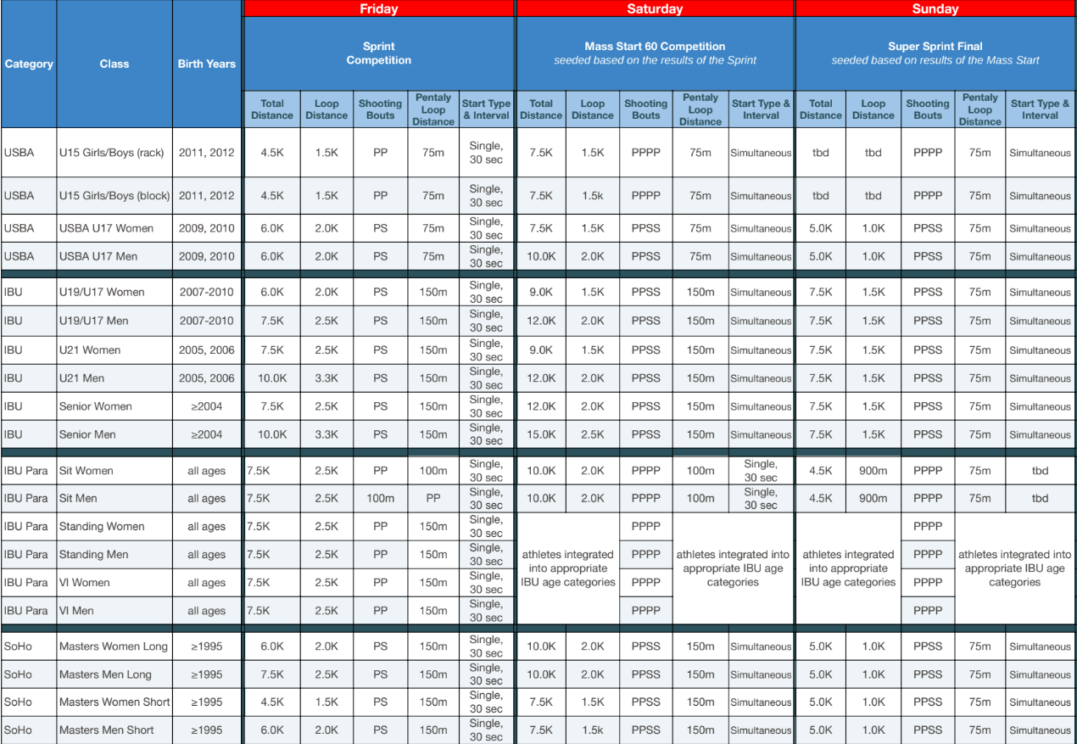

Important Notes:
- U15's Rack to Rack - Shooting in prone with cuffs without a block. Second half of shooting bouts will be on standing targets.
- U15's Block - Shooting in prone with a block. Second half of shooting bouts will be on standing targets.
- Biathletes younger than U15 wishing to "compete up" in the U15 class:
  - Must be able to safely compete in the designated format
  - Birth year must be 2013 or 2014
  - Must have a USBA membership and have completed Basic Rifle Safety
  - Must submit an email from their coach to the Race Secretary attesting to their ability to safely compete in the designated format
- Sr. Men & Sr. Women Class - Anyone can self-select into this Elite Senior category if older or younger.
- Masters’ athletes may choose Long or Short at their discretion. Top 3 overall women and men in long and short categories will receive awards. Official race results will be displayed in standard categories:
  - Master Women 30-39, Master Men 30-39, Sr Master women 40-49, Sr Master Men 40-49, Veteran Master Women 50-59, Veteran Master Men 50-59, Sr Veteran Master Women 60-69, Sr Veteran Master Men 60-69, Sr Veteran Master Women II 70+, Sr Veteran Master Men || 70+

Competition

The competition will include a Sprint race on Friday March 27th, and Mass Start 60 race on Saturday March 28th, and a Super Sprint Final on Sunday March 29th.

2026 U.S. Biathlon Senior Nationals & Spring Festival (more details to come!)
Thursday March 26th
8:00am – 11:00am: Official Training
4:00pm: Virtual TCM – link to come
Friday March 27th
7:00am - 8:45am: Athlete check-in & Bib pick up (North side of Sports Discovery Center)
7:45am – 8:45am: M/W Zero
8:50am – 1:00pm: Sprint (more detailed schedule to come)

Saturday March 28th
7:00am - 8:45am: Athlete check-in & Bib pick up (North side of Sports Discovery Center)
7:45am – 8:45am: M/W Zero
8:50am – 1:00pm: Mass Start 60 (more detailed schedule to come)
4:00pm – 5:30pm: Awards Celebration (drinks and appetizers), 2nd floor event space
- Note: The Awards Celebration is in place of the Banquet that historically occurs. Everyone is invited, no need to Register/Pay for this. This is included in your registration fees.
Sunday March 29th
7:00am - 8:45am: Athlete check-in & Bib pick up (North side of Sports Discovery Center)
7:45am – 8:45am: M/W Zero
8:50am – 1:00pm: Super Sprint Final (more detailed schedule to come)
Awards to Follow

Unofficial Training and Events

Open training will be available on the venue on the days leading up to the competition days. More details to come on when the courses will be marked. Trail fees and Range fees will be required. For those of you training on the venue for 10+ days, taking advantage of a Season Pass will be the best deal. Daily venue fee structure below:

Daily Ski Pass Adult = $24.00
Daily Ski Pass U18 = $12.00
Daily Range Fee = $10.00

These passes can be purchased at the Lodge upon arrival.

Awards

Awards will be presented for Fridays and Saturdays races at the Awards Celebration at 4:00pm on Saturday March 29th. Awards to following the completion of racing on Sunday for the Super Sprint event.
- This event will serve as the official U.S. Biathlon Senior National Championships. Thee top three in the IBU Senior category for men and women will be recognized with National Championship titles.
- Prize Money* will be awarded in the Senior Sprint and Mass Start events (1st = $750, 2nd = $500, 3rd = $250). The Sprint competition on Thursday, March 27th event will serve as Collegiate National Championships and the top three men and women in the Sprint event with collegiate affiliations will be recognized, along with the top three overall teams. *To be eligible for prize money, athletes must be U.S. citizens and USBA members in good standing.

Registration and Fees

Registration Click HERE

- NOTE: ALL coaches must Register (for free) and must be in good standing as a USBA Coach with a current SafeSport & Background Check in order to be assigned a Coaches Bib.
- Soldier Hollow expects all participants to have completed their U.S. Biathlon Basic Rifle Safety (BRS) Certification. The course can be completed at https://center.usbiathlon.org/ (or on the phone app), and the required in-person assessment should be taken at their home club in advance. If for some that is not possible, Official USBA Safety Assessors will be available during official training & zero times. Please identify yourself as needing to complete this responsibility before your first race.
- Pricing Structure:
  - $150.00 for all 3 races OR $55.00 per race
  - A late fee of $25 for 3 races OR $5 per single race will be added after March 4th.

Event Page

Event Website

Course Maps

Coming soon!

Lodging

Heber Valley is home to a variety of lodging and dining options for teams, athletes, families, and friends, among them are Homestead and Zermatt Utah in Midway, Utah. Contact information can be found for all options on the local chamber website at www.gohebervalley.com.

Zermatt Utah
784 West Resort Drive, Midway, UT 84049
For individuals, families, or teams under 10, please call Zermatt reservations 435.709.9527 and ask for the ‘Soldier Hollow’ rate (based on availability). The rate offered for all room types will be 15% off the best price on Zermatt’s website.
Group Reservations (10 or more rooms per night)
- Contact: Zermatt Sales
- rfp@zermattresorts.com
Midway Vacation Properties
(home, condo, townhome rentals)
Website: staymvp.com Midway Vacation Properties 840 W Bigler Lane
Midway, UT 84049
(888) 435 4204
info@midwayvp.com

Residences at Utah Olympic Park
Book a stay to take advantage of:
- Park City’s best nightly lodging rates
- Modern Hotel Rooms
- Unbeatable proximity to the Utah Olympic Park and surrounding ski resorts
- Guest kitchen and catering space to take care of all your meal needs.
- Complementary meeting/video review space
More information about our facility and accommodations can be found here.
Book your discounted event lodging with us here: https://hotels.cloudbeds.com/reservation/ggdeS7#promo=Comp23%2F24

Best Western Plus Heber Valley Hotel
Hotel Website
1227 S. US Highway 40
Heber City, UT 84032
435-657-6500

