Solder Hollow Super Qualifier Cross-Country Ski Races & RMISA Ute Invitational

Hosted by

Soldier Hollow Nordic Center

Midway, UT

January 22-25, 2026

Events are U.S. Ski & Snowboard / FIS Sanctioned

ACTIVE U.S. Ski & Snowboard License/Membership
REQUIRED For ALL ATHLETES and COACHES

ALL CURRENT INFORMATION AND UPDATES – website and email

Super Qualifier Event Page

REGISTER NOW - SOHO Super Q

For questions, please contact:
Race Administrator
Josh Korn
(801) 624-0809
jkorn@uolf.org

XC RACE ADMINISTRATION as of 12/6/2025

Chief of Competition – Bill Pierce
(612) 590-1427
bpierce@uolf.org

Race Administrator – Josh Korn
(801) 624-0809
jkorn@uolf.org

Chief of Course – Andre Crouch
Chief of Stadium – Jerry Richardson
Chief of Timing – TBD
Chief of Start – Tom Doherty
Chief of Finish – Terry Davis
Volunteer Lead – Kenzie Bennion
Medical Coordinator, IHC – Jennifer Kimball
Announcer - Matthew Heimburger
Chief of Grooming – Rion O’Grady

Cross Country Officials

Timing Contractor – Muddy Dog Sports
https://www.muddydogsports.com/

FIS Technical Delegate – Meg Seifert

Assistant Technical Delegate – Tom Bonacci

USSS Representative – Art Myshrall

Jury
Bill Pierce
Meg Seifert
Art Myshrall

REGISTRATION INFORMATION
ALL COACHES AND ATHLETES MUST REGISTER VIA MYRACE RESULT LINK:
REGISTER NOW

NO team spreadsheets will be accepted for registration purposes. ALL USSS Memberships will be cross checked prior to competing! You will NOT be allowed to race without a current and active USSS Membership.

Coaches: An active U.S. Ski & Snowboard coach license is required at the time of entry, MUST REGISTER AND HAVE VALID COACHES BIB TO BE IN CONTROLLED AREAS ON VENUE

Registration w/o Late Fee closes @ 11:59 on Friday January 16th ,2026.

Late Registration fees of $10 per entry per race. Late Registration closes @ 5:00pm on Tuesday January 20th, 2026.

Entries posted for verification: 9:00am Wednesday, January 21st.
- Entry List will be posted on: Muddy Dog Sports
- The Spreadsheet will have a list of all entries with their name, birth date, gender, class, affiliation, USSS number and USSS points. Coaches, athletes, and parents are responsible for checking this spreadsheet to verify the information.
- Changes/fixes may be submitted until 6:00pm MST, Wednesday January 21st.
Refunds: Accepted until 9:00am MST, Wednesday, January 21st.
- Direct all refund requests to Race Administrator – Josh Korn – jkorn@uolf.org
- All requests after this time won’t be accepted for any reason.
Scratches: Accepted until 12:00pm MST, Thursday, January 22nd.
- Direct all changes to Race Administrator – Josh Korn – jkorn@uolf.org
- Scratches after this date will not be accepted or recorded.
NOTE: We are generating start lists BEFORE the virtual Team Information Meeting.

ENTRY FEES

Per Race LATE FEE

Individual Athletes U8/10, U12, U14 $30.00 Add $10.00 per race per athlete.

Individual Athletes U16, U18/20 $45.00 Add $10.00 per race per athlete.

RMISA Team Fees (up to 6 men) $225.00 Athletes above quota, $45 per race

RMISA Team Fees (up to 6 women) $225.00 Athletes above quota, $45 per race

RMISA Team Registration, no later than 5pm MDT on Tuesday January 20th.

TRAIL PASSES REQUIRED JAN 22nd AND EARLIER
*NOTE: A $8 training fee for Thursday Jan 22nd is automatically added to each athlete’s registration upon checkout!

All competitors/coaches must purchase a trail pass or display season pass during training days.

Passes may be purchased at the NEW Nordic Center prior to skiing. Check in at the Nordic Center is required.

Glide Wax Call for XC Races: 12:00pm MST, Tuesday, January 20th and Wednesday, January 21st. If conditions look to be stable, we will try to make the call for both days on Tuesday to help with your pre travel wax prep.
- Friday Classic Sprint – TBD
- Saturday Skate Individual Start Dist. – TBD
- Sunday Classic Mass Start Dist. – TBD
- See summary of IMD/Event Wax Policy - IMD Wax Policy

FOOD and BEVERAGE

The Basecamp Café in the NEW Nordic Center lodge will be open during the races. They will have hot drinks, beverages, lunch offerings and snacks available for purchase.

WARMING, TOILETS and PARKING

- With the NEW Competition Building now complete, we will have the following amenities
  - Café – Main Level
  - Fireplace and sitting area – Main Level
  - Indoor restrooms – all three levels of the building
  - Dedicated Athlete warming area – 2nd level
- This year will be utilizing the Indoor restrooms which are located on all three levels of the new Competition building.
- Parking for Team vehicles will be allowed in marked areas by parking Permit only, each team will be given 1 Parking Pass for the Team Parking adjacent to the Testing Area (to be distributed to each team upon arrival in the Race Office). Overflow Team parking will be in the large lot as you enter the venue (this area will be clearly marked).
- Athlete Drop off – Each Team will also be given 2 Athlete Drop off Passes (pick up in Race Office upon arrival). These will allow you to come into the lower lot, drop athletes, coaches, supplies off, but not allow you to park in the lower lot. Upon drop off, you will have 5 minutes to get back to the Overflow lot.
- NO Outdoor Power Access – Generators allowed.
- Teams will be allowed to set up tents in the Warmup Stadium. ALL entry to this area will be directed through the South side of the Competition building parking lot.
- Team Trailers will be allowed to park in Team Parking allocated areas as indicated below and can stay there for the duration of the event.
- SEE IMAGE BELOW:
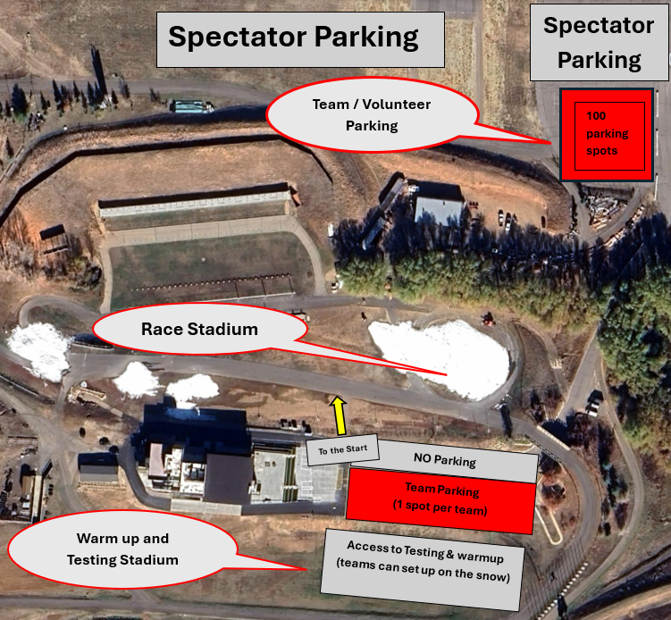

- Parent/Spectator parking will be allowed in the large lot as you enter the venue and the gravel parking area to the North of the Biathlon Range. These parking lots will have parking attendants present. Please stress to parents the importance of carpooling.
- NO access through the shop gate
SEEDING and RESULTS

XC Seeding: Based on the best of FIS or USSS points.

- Scoring will occur accordingly for NRL and FIS.
Live XC Timing (Muddy Dog Sports) during the races.

COURSE MAPS
Due to Biathlon races on our schedule at the end of March, we are currently planning to run the Super Q courses out of our Biathlon stadium, as we did for Super Q in 2024. Subject to Change!
Friday Jan 23rd – 1.12k course (all ages)
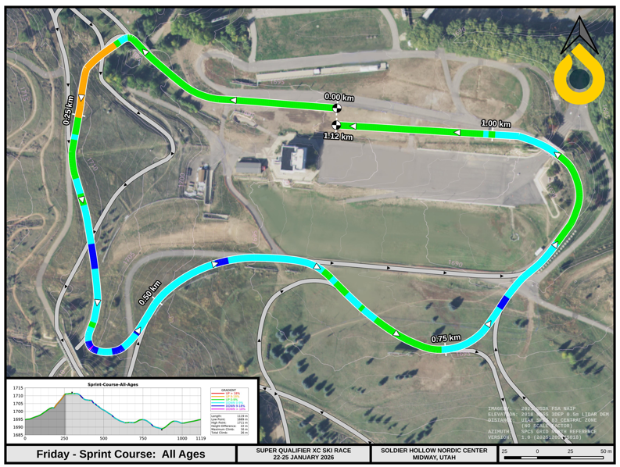

Saturday Jan 24th – Skate Interval Start
2k (1 x 2k) U8/U10
4k (2 x 2k) U12/U14
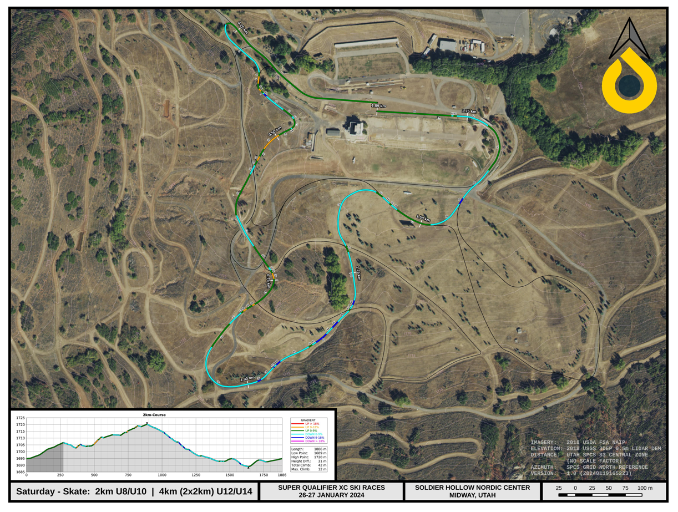

5k (2 x 2.5k) U16
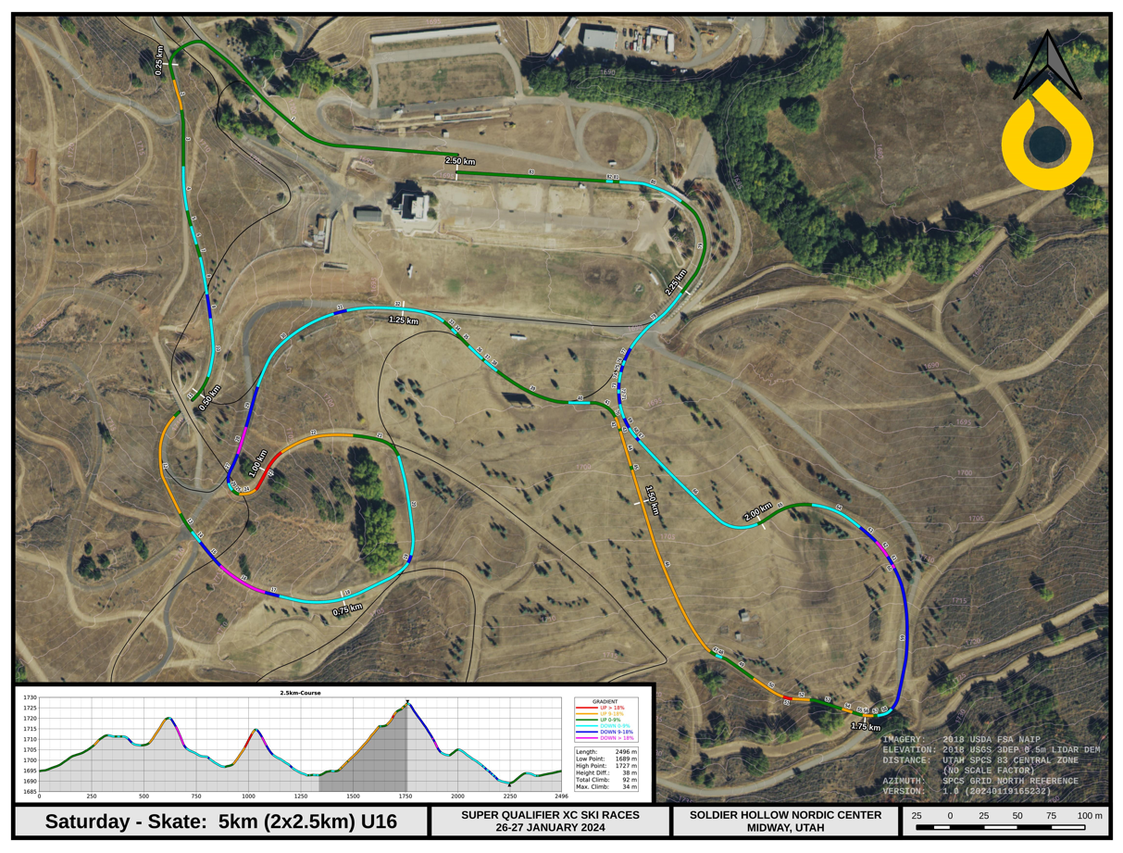

7.5k (2 x 3.75k) U18/U20/RMISA
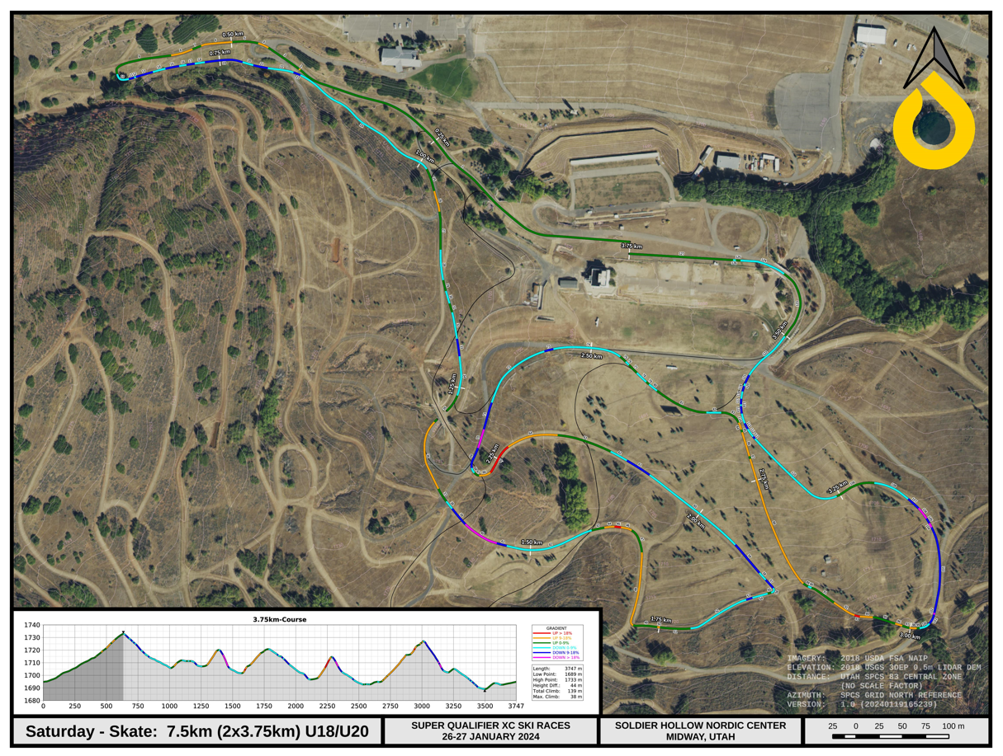

Sunday Jan 25th – Classic Mass Start RMISA / U16 and up
15k (4 x 3.75k) RMISA / U16 and up

AWARDS

- Super Q awards (Friday and Saturday)
  - Top three in these combined categories daily
    - U8/U10
    - U12/U14
    - U16
    - U18/20

- RMISA (Saturday and Sunday)
  - University of Utah to Manage College awards

- NON-RMISA (Sunday) – Racing age 14 years old and above (YOB 2011 or older)
  - Lapped athletes will be pulled in the 15k mass start to insure a safe and fair race!
  - Soldier Hollow to award Top 3 men and women
    - U16
    - U18/U20

NOTE: Please share with all parents/coaches/athletes to eliminate questions and concerns regarding age awards when the time comes.

WAX FACILITIES

- NO Wax Cabins
- NO power available, but team gas powered generators will be allowed.
- Testing and wax benches allowed in XC/Testing stadium.

LODGING FOR 2025/26 EVENTS

Lodging Options
Heber Valley is home to a variety of lodging and dining options for teams, athletes, families, and friends, among them are Homestead and Zermatt Utah in Midway, Utah. Contact information can be found for all options on the local chamber website at www.gohebervalley.com.

Zermatt Utah
784 West Resort Drive, Midway, UT 84049
For individuals, families, or teams under 10, please call Zermatt reservations 435.709.9527 and ask for the ‘Soldier Hollow’ rate (based on availability). The rate offered for all room types will be 15% off the best price on Zermatt’s website.
Group Reservations (10 or more rooms per night)
- Contact: Zermatt Sales
- rfp@zermattresorts.com
Midway Vacation Properties
(home, condo, townhome rentals)
Website: staymvp.com Midway Vacation Properties 840 W Bigler Lane
Midway, UT 84049
(888) 435 4204
info@midwayvp.com

Residences at Utah Olympic Park
Book a stay to take advantage of:
- Park City’s best nightly lodging rates
- Modern Hotel Rooms
- Unbeatable proximity to the Utah Olympic Park and surrounding ski resorts
- Guest kitchen and catering space to take care of all your meal needs.
- Complementary meeting/video review space
More information about our facility and accommodations can be found here.

SCHEDULE OF EVENTS

All Times are MST (Mountain Standard Time)

Subject to change as of 11/24/2025

Fri, Jan 16 | 11:59 pm | Early Registration closes
Tues, Jan 20 | 12:00 pm | OC to declare chosen Glide Wax for Friday Jan 23rd event – TBD
Tues, Jan 20 | 5:00 pm | Late Registration closes - $10.00 fee per entry per athlete
Wed, Jan 21 | 9:00 am | Entries posted on Muddy Dog Sports
Wed, Jan 21 | 12:00 pm | OC to declare chosen Glide Wax for Saturday Jan 24th event – TBD
Thurs, Jan 22 | 7:00 am – 7:00 pm | 7:00am – Race Office Opens  8:30am – Café Opens (main level of Nordic Center)  9:00am – Athlete Warming Area opens (2nd level of Nordic Center)  9:00am – 4:00pm - Training / Inspection. Courses marked and open for inspection. (Trail Pass Required)  2:00pm – Start Lists available at Muddy Dog Sports  6:00 pm Virtual Team Information Meeting – Zoom  Link to be provided

Fri, Jan 23 | 7:00 am | Race Office Opens
Fri, Jan 23 | 7:00am | Bib Distribution – Bib Room (West side of Comp building across the hall from Race Office)
Fri, Jan 23 | 7:15 am | Course open to coaches
Fri, Jan 23 | 7:45 am | Course opens to athletes / Athlete Warming Area opens
Fri, Jan 23 | 8:00 am | Café Opens (main level of Nordic Center)
Fri, Jan 23 | 8:35 am | Course closed
Fri, Jan 23 | 8:45 am – 4:15 pm | Classic Sprint  8:45am – Men Classic Sprint Qualifying Starts (U16, U18/20, OPEN)  - U18/U20/OPEN  - U16  10:00am – Women Classic Sprint Qualifying Starts (U16, U18/20, OPEN)  - U18/U20/OPEN  - U16  10:55am - 11:45am – Men/Women (U14 and Under) Classic Sprint Qualifying  12:00pm – 12:30pm – Men/Women (U14 and Under) Coach Run Royal Court (TBD)  12:35pm – U14 and down awards (U12/14 combined & U8/10 combined)  12:40pm – U18/20 Men Heats Start  1:05pm – U18/20 Women Heats Start  2:20pm – U18/20 Men Awards  2:20pm – U16 Men Heats Start  2:25pm – U18/20 Women Awards  2:45pm – U16 Women Heats Start  4:00pm – U16 Men Awards  4:05pm – U16 Women Awards
Sat, Jan 24 | 6:30 am | Race Office Open – Testing stadium open (must have bibs on)
Sat, Jan 24 | 7:00 am | Bib Distribution - (West side of Comp building across the hall from Race Office)
Sat, Jan 24 | 7:15 am | Courses open to coaches
Sat, Jan 24 | 7:45 am | Courses open to athletes / Athlete Warming Area opens
Sat, Jan 24 | 8:00 am | Café Opens (main level of Nordic Center)
Sat, Jan 24 | 8:50 am | Courses closed
Sat, Jan 24 | 9:00 am – 3:25 pm | Skate Interval Start  9:00am – Women/Men Interval Start Skate, U18/20/RMISA (2 x 3.75k loop)  Start Order  RMISA F / U18/U20 F – 9:00am  RMISA M / U18/U20 M – 9:50am  - Done by 11:00am  11:20am – 11:40am – RMISA Awards & U18/U20 M/F Awards  12:00pm – Women/Men Interval Start Skate, U16 (2 x 2.5k loop)  Start Order  U16 F – 12:00pm  U16 M – 12:40pm  - Done by 1:35pm  1:55pm – 2:05pm – U16 M/F Awards  1:50pm – Women/Men Interval Start Skate, U12/U14 (2 x 2k loop), U8/U10 (1 x 2k loop)  Start Order  U14 F – 1:50pm  U14 M – TBD  U12 F – TBD  U12 M – TBD  U10 F – TBD  U10 M – TBD  U8 F – TBD  U8 M – TBD  - Done by 2:55pm  3:10pm – 3:25pm – U12/U14 combined M/F Awards & U8/U10 combined M/F Awards
Sun, Jan 25 | 6:30 am | Race Office Open – Testing stadium open (must have bibs on)
Sun, Jan 25 | 7:00 am | Bib Distribution - (West side of Comp building across the hall from Race Office)
Sun, Jan 25 | 7:15 am | Courses open to coaches
Sun, Jan 25 | 7:45 am | Courses open to athletes / Athlete Warming Area opens
 | 8:00 am | Café Opens (main level of Nordic Center)
 | 8:50 am | Courses closed
 | 9:00 am – 12:25 pm | Classic Mass Start  9:00 am – Men’s RMISA / Open Mass Start Classic 15k (4 x 3.75k)  Last finisher – Approx 9:50am  Course opens – Approx 9:50am  Men’s Awards – 10:10am – 10:35am - U16, U18/20, RMISA  Course closes – 10:35am  10:40 am – Women’s RMISA / Open Mass Start Classic 15k (4 x 3.75k)  Last finisher – Approx 11:40am  Women’s Awards – 12:00pm – 12:25pm - U16, U18/20, RMISA + Overall RMISA awards
 |  | Thanks for coming and Travel Safe!

